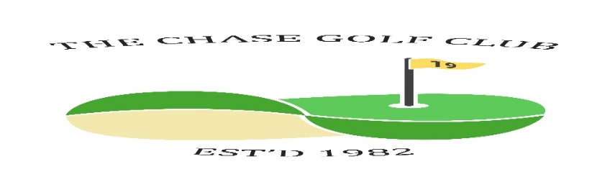
The Chase Golf Club

Competition Draw Sheet - May Medal + Q2
Dates: Wed May 8th Fri 10th Sat 11th Sun 12th Venue Seafield

Time &  initials | Wednesday Draw
 | S Smith | G Cavanagh | D Edgar | H Mackie
 | A Smeeton | J Brodie | J Burnett | S Kelly
Time &  initials | Friday Draw
 | E Borland | G Christie | J Bryden
Time &  initials | Saturday Draw
 | R Greenwood | T Bloor | A Muir | D Beattie
 | M Mancini | R McCubbin | S Hannah | S Kirk
Time &  initials | Sunday Draw
 | I Speirs | W Rae
 | R Gilchrist | J Taylor | I Gray | J Cathcart
Now the draw has been made you are not able to change days without express consent from a Committee member under the permitted playing conditions. Failure to contact a Committee member will lead to disqualification.
Format | 18 holes white | Handicaps | Strokeplay Max 28 | Prizes | More than 10 players 1/2/3  Less than 10 players 1/2  Less than 5 is winner only
N.B. If you withdraw from a game, then you must contact all players in your group to let them know. Failure to do so will result in players left without a game and the Committee will take action against offender(s).

